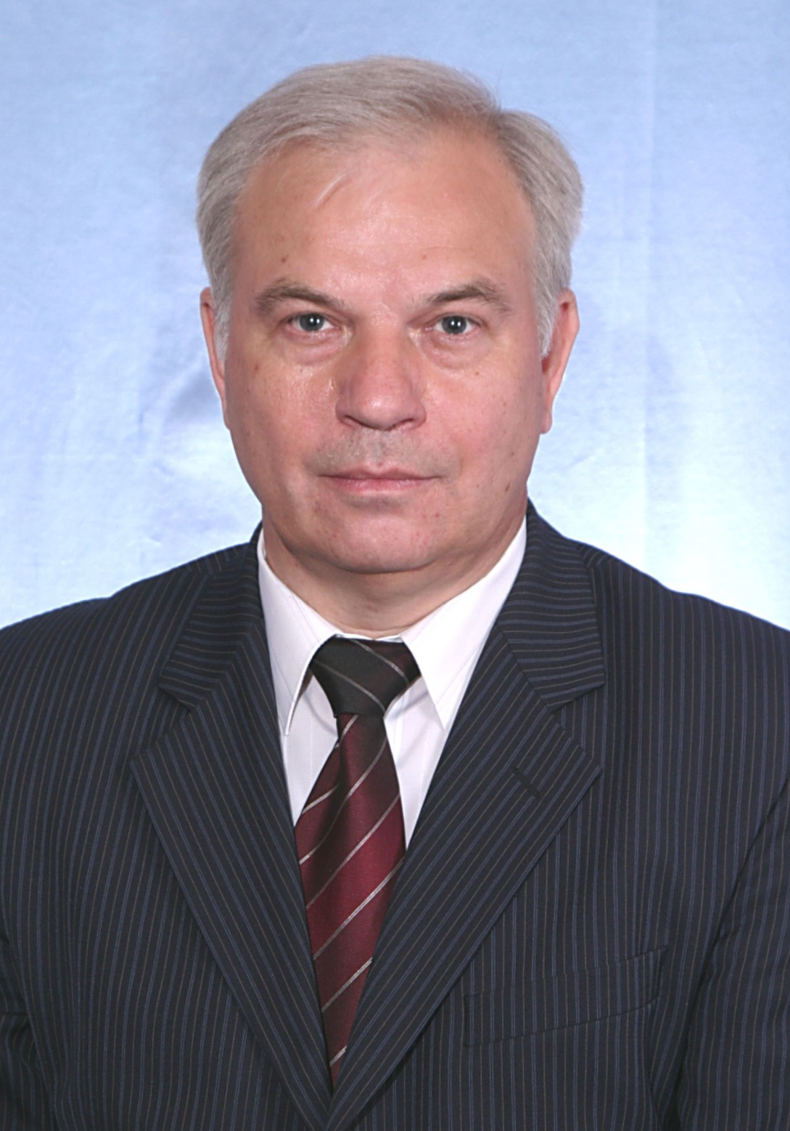

**Vladimir Torshin** was born in 1951, Doctor of Biological Sciences, Professor, Head of the Department of Hominal Physiology, Medical Institute of the Peoples' Friendship University of Russia.

In 1978 he graduated from the Biological Faculty of Moscow State University named after M.V. Lomonosov. From 1978 to 1980 worked in the laboratory of pathophysiology of the nervous system of the Research Institute of General Pathology and Pathological Physiology of the USSR Academy of Medical Sciences. In 1980, he entered graduate school at the Department of Hominal Physiology of the Peoples' Friendship University of Russia and after graduation in 1983, he worked at this department. In 1993 he defended his Doctoral Thesis and in 1998 he was awarded the academic title of professor.

V. Torshin published more than 300 works, including 3 monographs, 25 study guides, 7 textbooks, received 4 author’s certificates and patents for inventions. He prepared for defense 2 Doctors and 8 Candidates of Sciences. V. Torshin is the Honorary Worker of Higher Professional Education of the Russian Federation.

Full member of the International Academy of Higher Education Sciences, Russian Environmental Academy. For many years, he was Chairman of the task group "Ecological and physiological problems of adaptation" of the Scientific Council on Experimental and Applied Physiology under the Presidium of the Russian Academy of Medical Sciences, was a member of the academic and methodological commission on hominal physiology at the Ministry of Health of the Russian Federation, a member of the board of the Moscow Society of Physiologists.

Research interests: study of epileptogenesis mechanisms, adaptation to hypoxia, biorhythms, ethnic physiology and human ecology. Study of the adaptation of students from different parts of the world to the conditions of Central Russia; study of the regulation mechanisms of the cardiovascular system in people of different ages and in representatives of various ethnic groups.