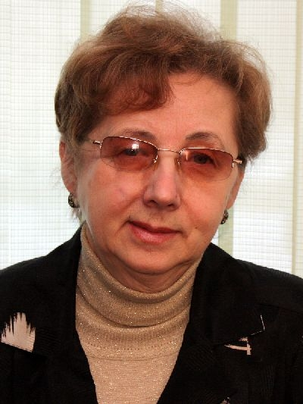

**Valeria Makarova,** Doctor of Medical Sciences, Professor, Head of the Department of Propaedeutics of Childhood Diseases and Outpatient Pediatrics of the Northern State Medical University, Honored Doctor of RF

|  |
| --- |
|  |
|  |

In 1972 V. Makarova graduated from the Department of General Medicine of the Arkhangelsk State Medical Institute. From 1972 till 1976 she worked as a local pediatrician of the Northern Basin Clinical Hospital named after N.A. Semashko (Arkhangelsk); from 1976 till 1978 – passed medical residency in pediatrics at the Arkhangelsk State Medical Institute (ASMI). From 1979 V. Makarova worked as an Assistant Professor in the Department of Pediatrics of ASMI. In 1983 she embarked on postgraduate studies to the Department of Propaedeutics of Childhood Diseases of Leningrad Pediatric Medical Institute and after graduation in 1986 passed PhD defense. Since 1987 V. Makarova headed the Department of Propaedeutics of Childhood Diseases and Outpatient Pediatrics of the Arkhangelsk State Medical Institute; was awarded a medical title of Associate Professor. In 1995 she defended Doctoral Thesis and in 1996 she was awarded a Professor degree.

V. Makarova published more than 500 works, including 6 monographs, more than 70 manuals and methodological recommendations, 7 textbooks, obtained 4 certificates and patents for inventions. Prepared for defense 3 Doctors and 30 Candidates of Sciences. Honored Master of Education and Science of Russian Academy of Natural History.

V. Makarova is a member of European Academy of Natural History, Russian Academy of Natural History. For many years she was a Chairman of the Dissertation Council at the Northern State Medical University and a member of the Dissertation Council at the Northern (Arctic) Federal University named after M.V. Lomonosov. V. Makarova is the editorial board member of journals “Rheumatology”, “Children’s Medicine of the North-West”, «Current Issues of Science and Education”. She is a Chief Pediatrician of the Ministry of Health Care of the Arkhangelsk Region.

Fields of scientific interests: children’s medical state in the European North of Russia, risk factors of heart and vessels pathology development in children and adolescents, musculoskeletal diseases in children.