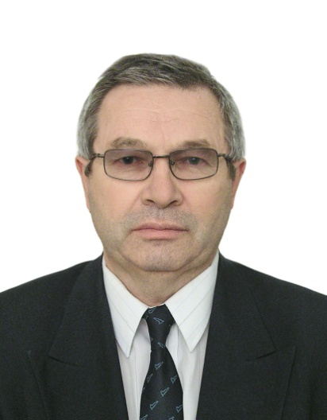

Boris Labudin

Doctor of Engineering, Professor of the Higher School of Engineering of the Northern (Arctic) Federal University.

1971 – B. Labudin graduated from Arkhangelsk Forest Engineering Institute with a degree in railway engineer and then completed post-graduate studies at Saint-Petersburg State Architecture and Civil Engineering Institute.

Under the leadership of B. Labudin the scientific school is fully functional in the field: "Improving of construction solutions and calculation methods of spatially regular and cyclically symmetric systems." The main research topics:

1) development and research of wood-engineered prefabricated buildings from modules of volume for the North Arctic region;

2) perfecting of construction solutions of multistory buildings using wood-engineered elements (LVL, CLT, CNT, etc.) and connections;

3) technical diagnostics of structural steel, buildings and constructions using non-destructive methods; reinforcement design of building constructions, buildings and structures in operation;

4) practical evaluation and revaluation of the market value of real estate properties;

5) biomechanics in sports and medical applications: structures, theory, experiment.

B. Labudin has proximate less 300 published scientific and educational materials, manuals, monographs; 32 inventions and patents, 19 articles in Scopus и Web of Science.
Member of Arkhangelsk Branch of All-Russian Society for the Preservation of Historical and Cultural Monuments, Chamber of Commerce and Industry; member of Experts’ Register on Timber, Forest Products, Wood Constructions, Harvesting Technique and Woodworking; member of Expert Body of Russian Academy of Architecture and Construction Sciences, member of Task Group of Interoperability Technical Committee 465 ”Building and Construction”; member of Buildings and Constructions Inspectors’ Association; Director of LLC “Arkhangelsk Restoration Workshops”; member of two Dissertations Boards (NArFU and Saint-Petersburg State University of Architecture and Civil Engineering; member of two editorships: «Human Ecology» (Arkhangelsk), “Materials. Constructions. Technologies” (Yoshkar Ola); full member of FIABCI.
Interests: classic and sacred music, chapel, travelling.

