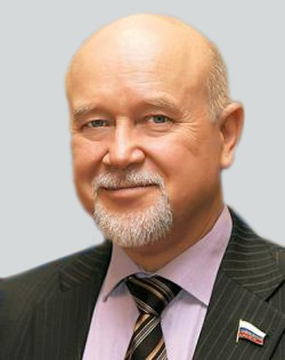

**Sergey Kolesnikov**, Doctor of Medical Sciences, Professor, Academician of the Russian Academy of Sciences.

From 1972 to 1987 he worked at the Institute of Clinical and Experimental Medicine of the Siberian Branch of Academy of Medical Sciences of the USSR (Novosibirsk). He started as a junior researcher and finished as a Deputy Director. He headed the laboratory of development physiology. In 1987−2014 - founder and Chairman of the East Siberian Scientific Center SB RAMS in Irkutsk.

In 1991, he was elected a corresponding member, and in 1997, an Academician of the RAMS (since 2013, RAS). In 2006−2014 – Presidium Member of the RAMS. Since 2001, Advisor of the Presidium of the Russian Academy of Medical Sciences and the Russian Academy of Sciences.

Since 2018, Deputy Chief Scientific Secretary of the RAS. Since 2011, Professor at Lomonosov Moscow State University and Moscow State Regional University.

Research interests: embryology, morphology, pathological physiology, toxicology, ecology, maternal and child health, and healthcare. Expert of RAS, RSCI, International Institute for the Suppression of Medical Counterfeiting (Paris), etc.

He trained more than 60 Doctors and Candidates of Sciences. Editor-in-chief of journal “Acta Biomedica Scientifica”, member of the editorial boards of 20 journals. The author of 26 monographs, 3 textbooks, 17 patents, more than 400 scientific articles, 11 drugs, hygienic medication and dietary supplements.

Awards and titles: Order of Friendship of Peoples, two Orders of Honor, medal "For Valorous Labor", Honored Scientist of the Russian Federation, Prize of the Russian Government in the field of science and technology. Mkhitar Gosh medal (State award of Armenia, 2013).

Honorary Citizen of Detroit (USA, 1985), Honorary Doctor of Kingston-on-Thames University (Great Britain, 1997), Honorary Professor of MIRBIS University, Moscow (2009).

Research Interests:

1. Morphology and embryology of humans and animals.

2. Toxicology.

3. Epidemiology and human ecology.

4. Pathological physiology (in particular, the mother-placenta-fetus system).

5. Organization and public administration of health and social services.