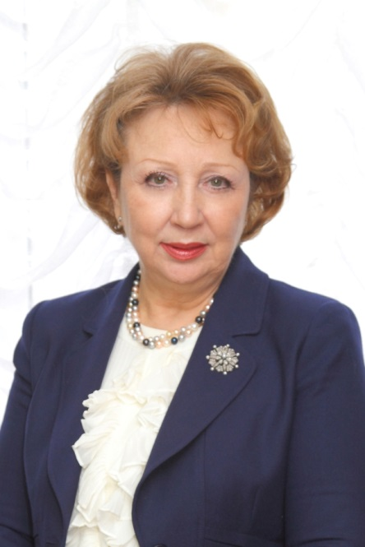 **Nina Zaitseva**

Academician of the Russian Academy of Sciences, Doctor of Medical Sciences, Professor, Honored Science Worker of the Russian Federation, Research Advisor of FBIS “FSC of Preventive Technologies on Risk Management of Public Health”, Perm. Scientific Interests: fundamental applied aspects of human ecology; regularities and mechanisms of environmental influence on the human health; risk analysis and preventive technologies for its reduction.

1969 - graduated from Perm Medical Institute.

1971 - medical residency in the Department of Communal Hygiene.

1973 – Candidate of Medical Sciences.

1978 – 1996 worked in the Department of Environmental Protection of Perm Technological University in the position of senior research fellow, assistant professor, professor.

1983 – admitted to a degree Doctor of Medical Sciences

1985 – conferred title - Professor of the Department of Environmental Protection

1996 –established and headed Perm Scientific and Research Institute of Children Environmental Pathology (at present FBIS “FSC of Preventive Technologies on Risk Management of Public Health” of Federal Service on Surveillance on Consume Rights Protection and Wellbeing).

A scientific school was established on the basis of the Center that develops modern methods of assessing health risks associated with the impact of heterogeneous environmental and professionally determined factors, as well as a system of damage evidence to public health and preventive technologies to minimize health risks. The developed methods are based on the analysis of monitoring results of habitat quality and working conditions and the associated health status of the population of Russia, data from in-depth clinical laboratory, chemicoanalytical, and epidemiological studies and are put into practice in the form of a set of guidance and research and information documents of Rospotrebnadzor.

Under the scientific supervision of N. Zaitseva 63 dissertations were defended including 21 doctoral and 42 master's.

N. Zaitseva is the author of more than 500 published scientific works, 58 authorship certificates and patents of the Russian Federation for inventions.