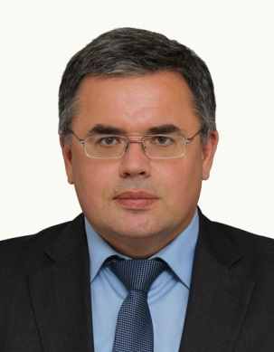

**Pavel ZHURAVLEV** (born 05.15.1974, Arkhangelsk), historian, political scientist, Candidate of Historical Sciences (2002), Associate Professor, Head of the Department of Science and Higher Education of the Ministry of Education and Science of the Arkhangelsk Region (since 2010), Honorary Worker of Higher Professional Education of the Russian Federation (2013), Advisor of the Russian Academy of Natural Sciences, Pomor Regional Branch (2006). In 1996, he graduated with honors from the Faculty of History and then passed Postgraduate Studies in Russian History of the Pomor State University named after M.V. Lomonosov. In 1996–2014 worked at the Department of Political Science and Sociology as an assistant, senior lecturer, Associate Professor, Head of the Department (since 2009). Since 1999, member of the Prize Award Commission named after M.V. Lomonosov of the Arkhangelsk Regional Government, since 2011 - Chairman of the Public Council, member of the Board of the Interregional Public Lomonosov Foundation. P. Zhuravlev was awarded the medal of the Russian Academy of Sciences “Lomonosov is 300 years” for the implementation of Decree of the President of Russia No. 1022 “On the celebration of the 300th anniversary of M.V. Lomonosov’s birth”.

Scientific interests: research in contemporary history, historical geography and political science of the Arctic and the European North, as well as modern scientology and regional politics in the field of science and education. P. Zhuravlev is the author of 84 scientific publications, including 3 monographs, 6 manuals and textbooks for universities. He participated in the preparation of 56 scientific collectors as a executive editor, member of the editorial board, redactor or reviewer.