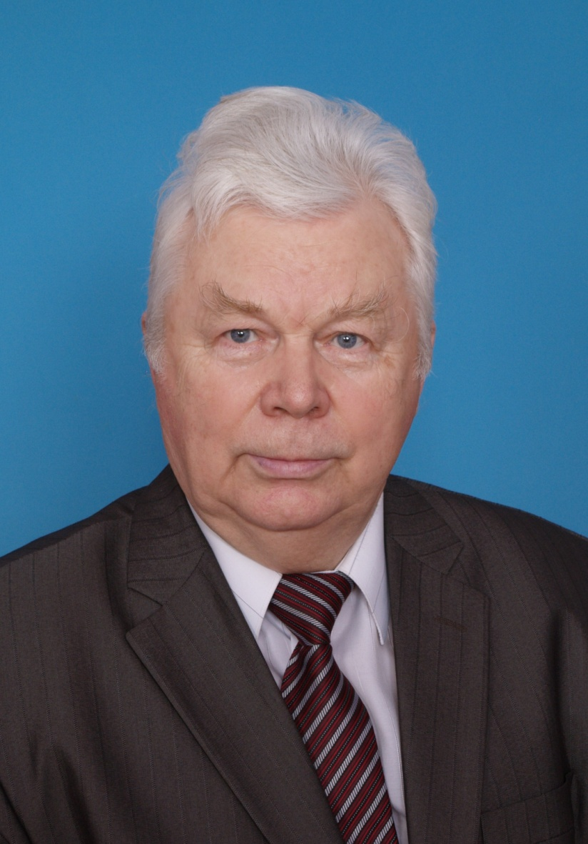

**Vitaly Bykov** - Doctor of Medical Sciences, Professor. After graduation from the Arkhangelsk State Medical Institute in 1966, V. Bykov worked in the district and regional hospitals for 22 years. Has the highest qualification grade in general and thoracic surgery. Since 1988 till present – a member of the Department of General, Operative and Hospital Surgery of NSMU started from Teaching Assistant then Assistant Professor then Head of the Department (1997−2014) and Professor.

Scientific fields: gunshot injuries of peace-time, purulent diseases of chest organs, chest and intra-abdominal injuries, urgent intra-abdominal diseases, history of medicine.

V. Bykov has 150 scientific papers and 7 patents for invention.